Assignment-7.4:

Write a word count program using Partitioner and implement the following logic in the Partitioner words with length 5 should go into reducer 1 and words with length 6 should go into reducer 2 and the rest of the words should go into reducer 3.

Driver Class:

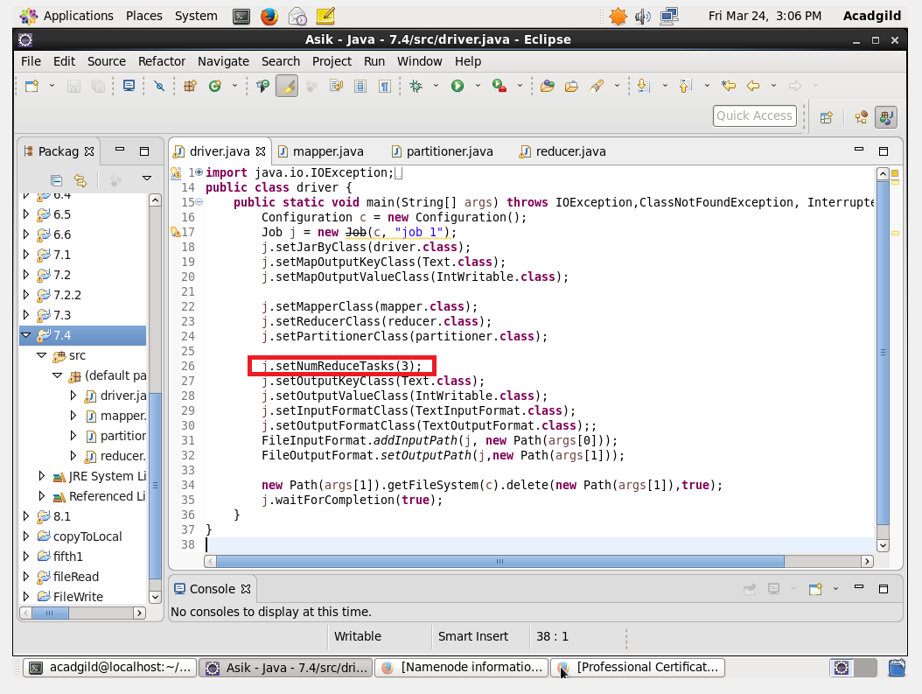

Mapper Class:

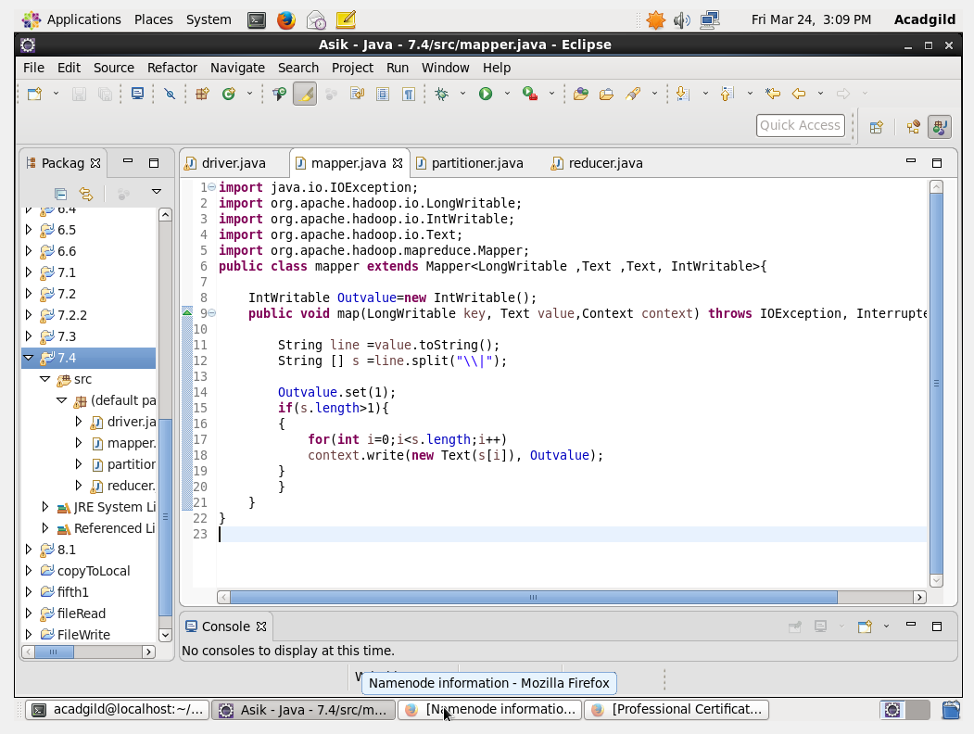

Reducer Class:

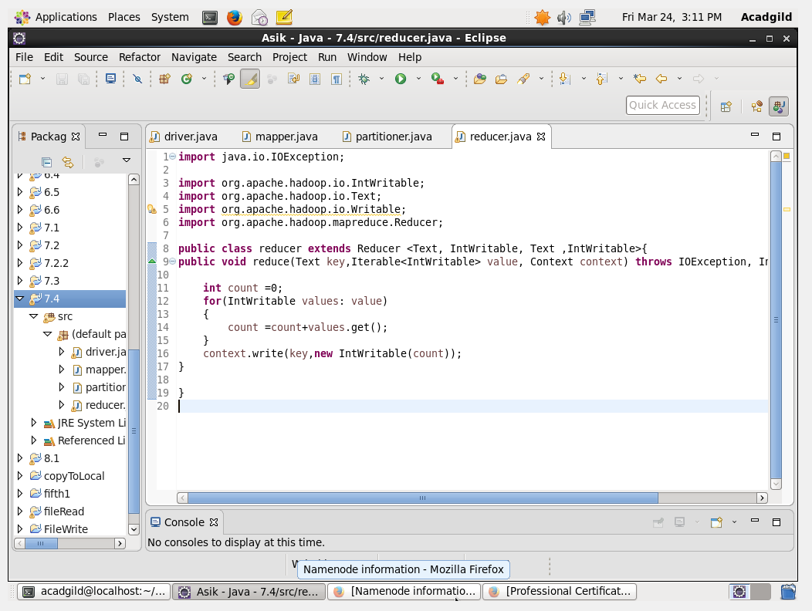

Partitioner Class:

Here In the Partitioner Class if the length of the word is equal to 5 then it will go to the first reducer, If the length is equal to 6 then it will go to the second reducer and everything else will go to the third reducer.

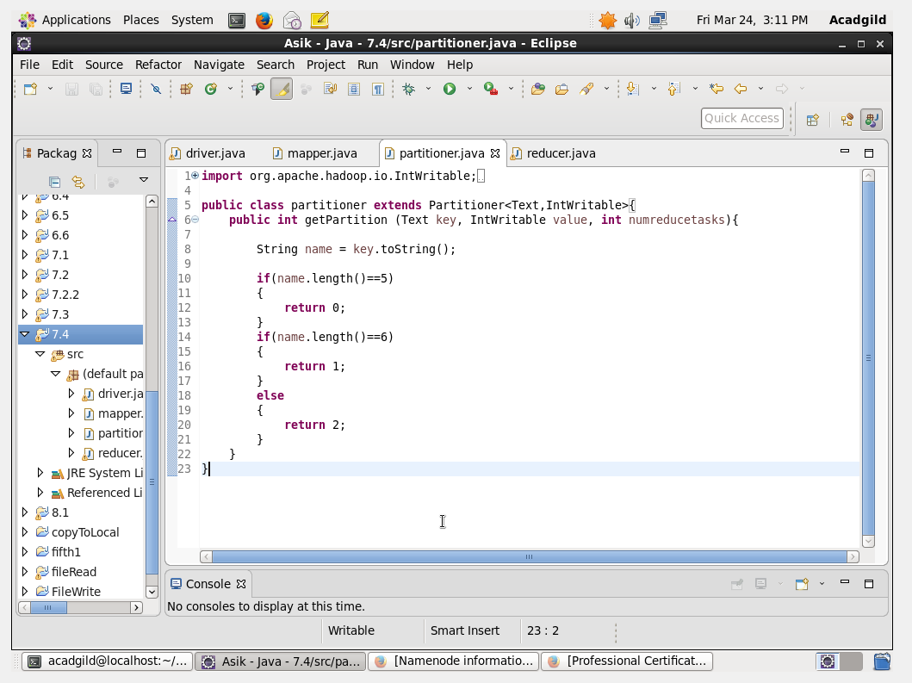

Output:

